**Robótica**

**Ejercicio 4. Movimiento de un robot diferencial mediante comandos de velocidad**

El código adjunto implementa la conducción de una base robótica con sistema diferencial mediante comandos de velocidad u = (v, w), v: velocidad lineal y w: velocidad angular. A partir de este código se pide:

1. Modifique el programa introduciendo una estructura *if-then-else* para que contemple el caso de velocidad angular (w) cero (movimiento en línea recta). En este apartado no existe incertidumbre en el sistema: ni en la pose inicial (matriz P3x3), ni en el movimiento (v, w) (matriz Q2x2).



Figure 1

In this figure, we see the ideal path of a robot using velocity and angular velocity.

1. Considere ahora error gaussiano en el movimiento: *Q* = diag ([SigmaV^2 SigmaW^2]);
   1. Introduzca el código que calcule la matriz de covarianza de la pose Pk, y dibújela como elipses.

*P*k *= JacFx * P*k-1 *\* JacFx' + JacFu * Q * JacFu';*

donde *JacFx* y *JacFu* son los jacobianos del movimiento con respecto a la pose *x* y acción *u*. Derive la ecuación de los jacobianos y compruébelas con la solución en los apéndices de las diapositivas.

* 1. Dibuje una marca en las poses *ground-truth* generadas aleatoriamente a partir de la Q

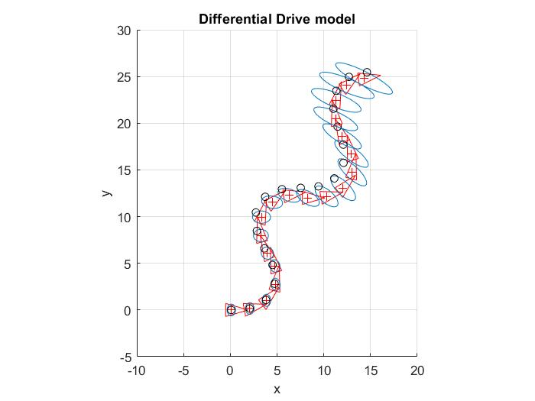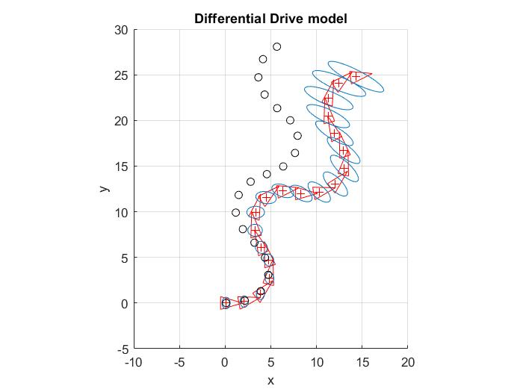

Figure 2 Figure 3

In these figures, we see the ideal path of a robot using velocity and angular velocity with the real position of the robot (represented by a circular point) and an ellipse which represent the possible location where can be the robot. This ellipse follows a gaussian distribution which change in every step of the robot, increasing its size and occupying more space, also changing the sigma.

function differential_motion_velocity

clear, close all

% PARAMETERS

dT = 0.1; %time steps size

v = 1; % Linear Velocity

l = 0.5; %Half the width of the robot

SigmaV = 0.1; %Standard deviation of the linear velocity.

SigmaW = 0.1; %Standard deviation of the angular velocity

nSteps =400; %Number of motions

%initial knowledge (prior at k = 0)

x = [0;0;0];

xtrue = x; %Ground-truth position (unknown)

P = diag ([0.2,0.4,0]); %pose covariance matrix 3x3

Q = diag ([SigmaV^2 SigmaW^2]); %motion covariance matrix 2x2

%-------- Set up graphics -----------%

figure (1); hold on; axis equal; grid on; axis ([-20 40 -5 45])

xlabel('x'); ylabel('y');

title ('Differential Drive model');

%-------- Main loop -----------%

for (k = 1: nSteps)

%control is a wiggle with constant linear velocity

u = [v; pi/10*sin(4*pi*k/nSteps)];

R = u (1) /u (2); %v/w Curvature radius

%jacobians

sx = sin (x (3)); cx = cos (x (3)); %sin and cos for the previous robot heading

si = sin (u (2) *dT); ci = cos (u (2) *dT); %sin and cos for the heading increment

if (u (2) ==0) %linear motion w=0 --> R = infinite

%JACOBIAN HERE

**JacF_x= [1 0 -v*sx*dT;**

**0 1 v*cx*dT;**

**0 0 1];**

**JacF_u= [cx*dT sx*dT 0;**

**0 0 0];**

else %Non-linear motion w=!0

%JACOBIAN HERE

**JacF_x= [1 0 R*(-sx*si-cx*(1-ci));**

**0 1 R*(cx*si-sx*(1-ci));**

**0 0 1];**

**p1= [cx*si-sx*(1-ci) R*(cx*ci-sx*si);**

**sx*si+cx*(1-ci) R*(sx*ci-cx*si);**

**0 1];**

**p2= [1/u (2) -v/ (u (2) ^2);**

**0 dT];**

**JacF_u=p1*p2;**

end

%prediction steps

%P = JacF_x*P*JacF_x' + JacF_u*Q*JacF_u';

%xtrue = DifferentialModel (xtrue, u+ [SigmaV; SigmaW]. *randn (2,1), dT);

x = DifferentialModel (x, u, dT);

%draw occasionally

if(mod(k-1,20) ==0)

DrawRobot(x,'r');

% PlotEllipse (x, P,0.5);

% plot (xtrue (1), xtrue(2),'ko');

end;

end;

%------------ MODEL --------------%

function y = DifferentialModel (x, u, dT)

%This function takes pose x and transform it according to the motion u= [v, w]

%applying the differential drive model.

% Dt: time increment

% y: Transformed pose (in world reference)

if (u (2) == 0) %linear motion w=0. Only motion in x

%dx = u (1) *dT; dy = 0; d_thetha = 0;

y (1,1) = x (1) + u (1) *dT*cos (x (3));

y (2,1) = x (2) + u (1) *dT*sin (x (3));

y (3,1) = x (3);

else %Non-linear motion w=!0

R=u (1)/u (2); %v/w=r is the curvature radius

y (1,1) = x (1) - R*sin (x (3)) + R*sin (x (3) +u (2) *dT);

y (2,1) = x (2) + R*cos (x (3)) - R*cos (x (3) +u (2) *dT);

y (3,1) = x (3) + u (2) *dT;

end